One-Drive Cheat Sheet
This cheat sheet will enable you to save your Office Documents on your computer automatically to One Drive. There will be no longer a need to save anything because it will automatically save.
Part 1: Where is One Drive? Part 2 Syncing Part 3 Sharing
- Sign into Wake ID: https://wakeid.wcpss.net

- Click on Office 365

- Click on One Drive

- Click on New to start a new document or create a new folder.

- Click on Upload to upload a document or entire folder from your computer.

Part 2: Syncing Automatically
- Want to Sync Automatically from Office to One Drive? Click Sync and then download One Drive. Follow the directions to download the program.

- How to find and Pin your One Drive
Open File Explorer Folder at the bottom of your computer.
Click on Windows C:
Click Users
Click on your Name

When you want to access your files from the File Explorer Folder

You can find it easily on the top under Quick Access.

- Sign Into Microsoft Office.
Sign in using your WCPSS Email account and then sign into your Wake ID.

- It Automatically saves to your computer and onto your One Drive.
Microsoft Office Word Document

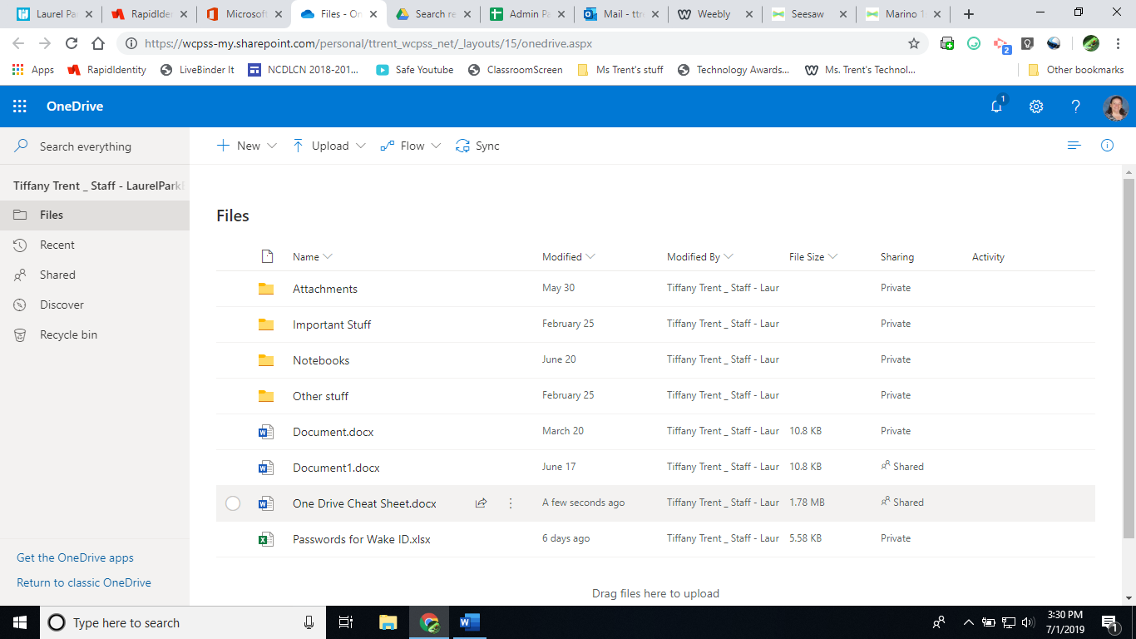
Online One Drive
Part 3: Sharing

One Drive Online:
Click on the 3 ellipsis dots. Click on Share.

I tried to be on the same document at the same time and it seems there is a bit of a lag, so it may not be as seamless as Google docs to share at type at the same time.
Share like you would on Google Drive. Anyone with the link, People at WCPSS with the link or specific people.
To make it view only – uncheck the allow editing button.

