Cheat Sheet on How Kids Use Board Builder to Share on Edmodo

1. Things I have learned – Internet Explorer sometimes does not show the boards children have created. Open Firefox or Chrome and they show up with no problem.
2. On Edmodo sometimes the link is messed up – I have done this a multiple times on all browsers with no problem. I think students are clicking on the link or changing the link in Edmodo before they share it.

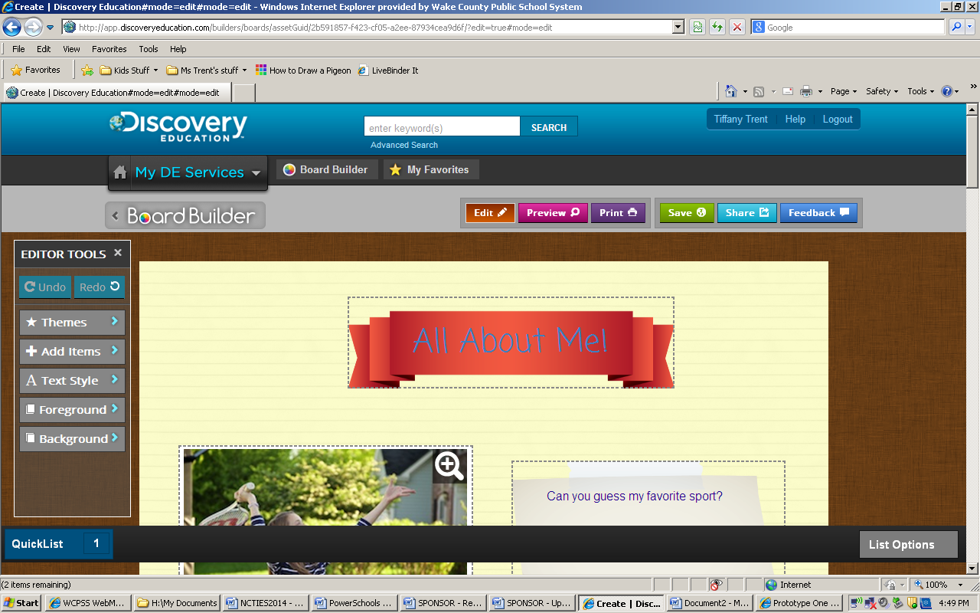

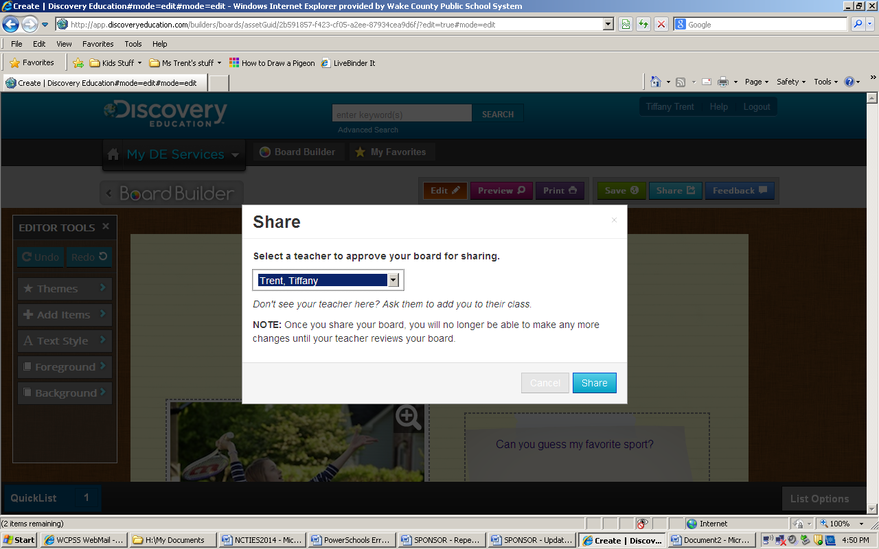

Pick the teacher who is evaluating your work.

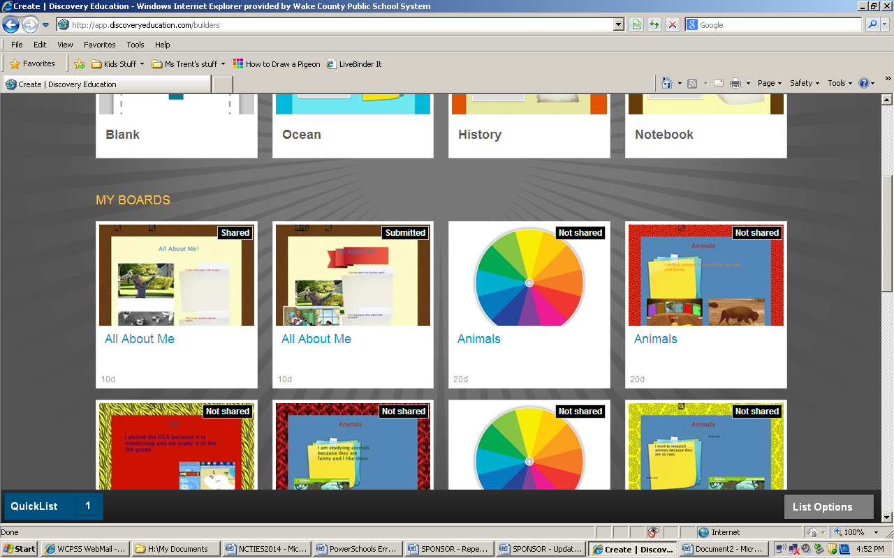

|  |
| --- |
| **TEACHER’S SCREEN**    Click Classroom Manager and Student Boards to see students who have submitted their boards.    Click on Review Board    Click Teacher Review. I always had a short conference with the student and press Yes, Share this Project if the student followed the directions and grammatical rules and writing conventions. You can also send feedback to students if you have to click No, Don’t share this project. |

**BACK TO THE STUDENT SCREEN**

Students can see Feedback by moving their mouse to the board and clicking the Feedback button.

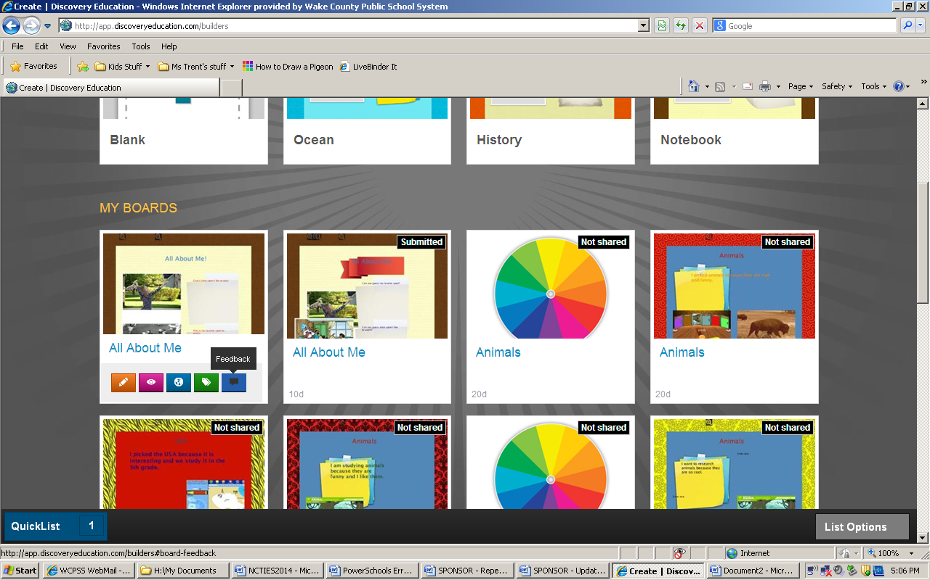

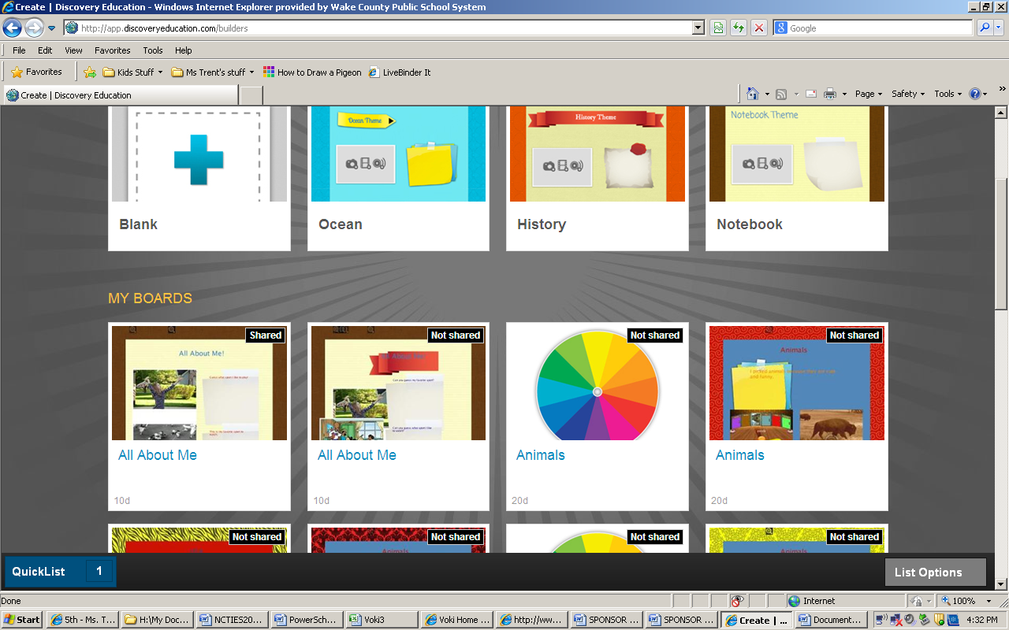

If the teacher Clicked “Yes, Share this Project” instead of no. Students can share their project on Edmodo by clicking in the middle of the one that says shared.

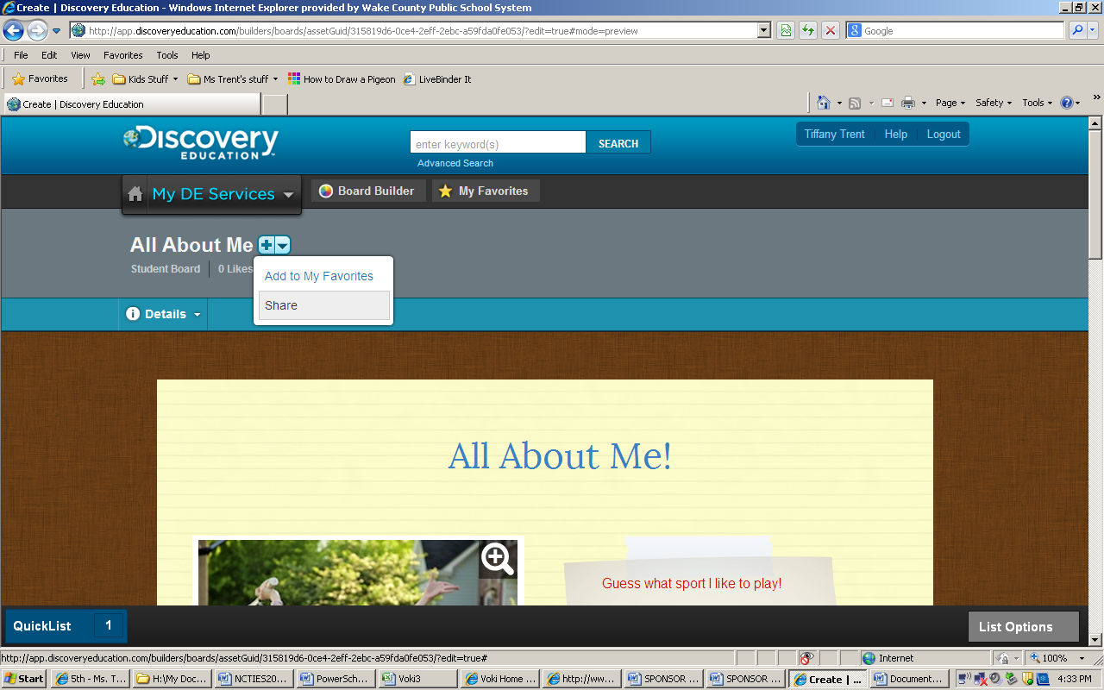

Click the dropdown triangle and click share.

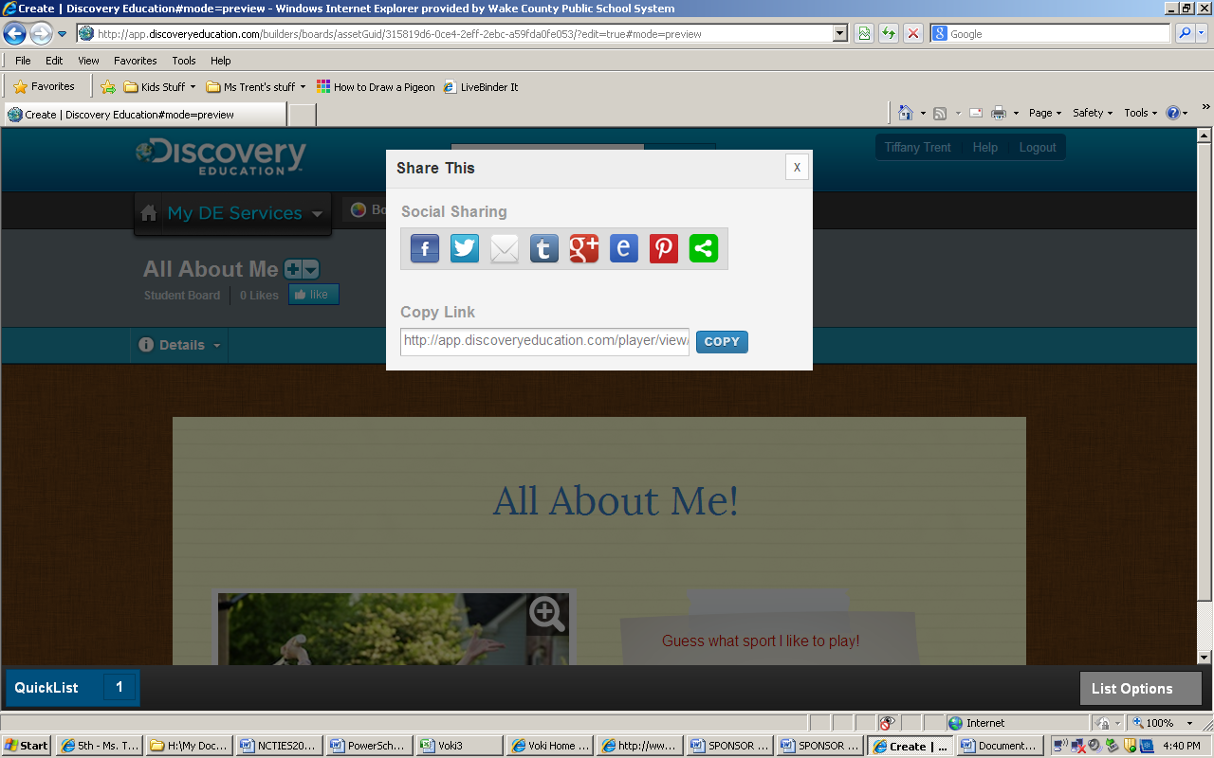

The kids click on E for Edmodo to share, or they could copy the link and paste it in Edmodo.

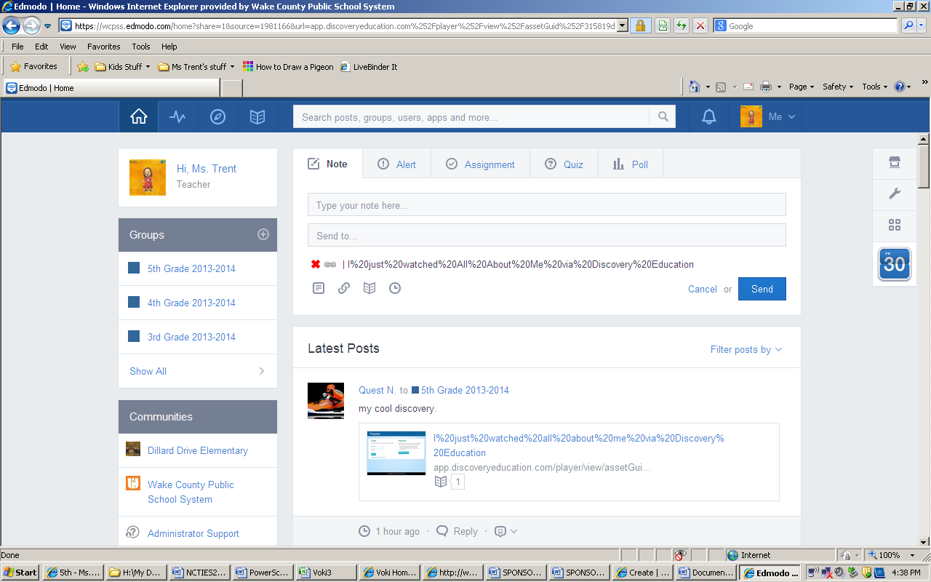

The link will automatically be there. Kids have to type their note and pick the group to send it to. Warn them not to click or change the link.

